Steps to save a quote for Parts Check for Auto IT Units XML Format

- Prepare quote and click on Print Preview and then Accept Order
- When the preview appears right click on the preview

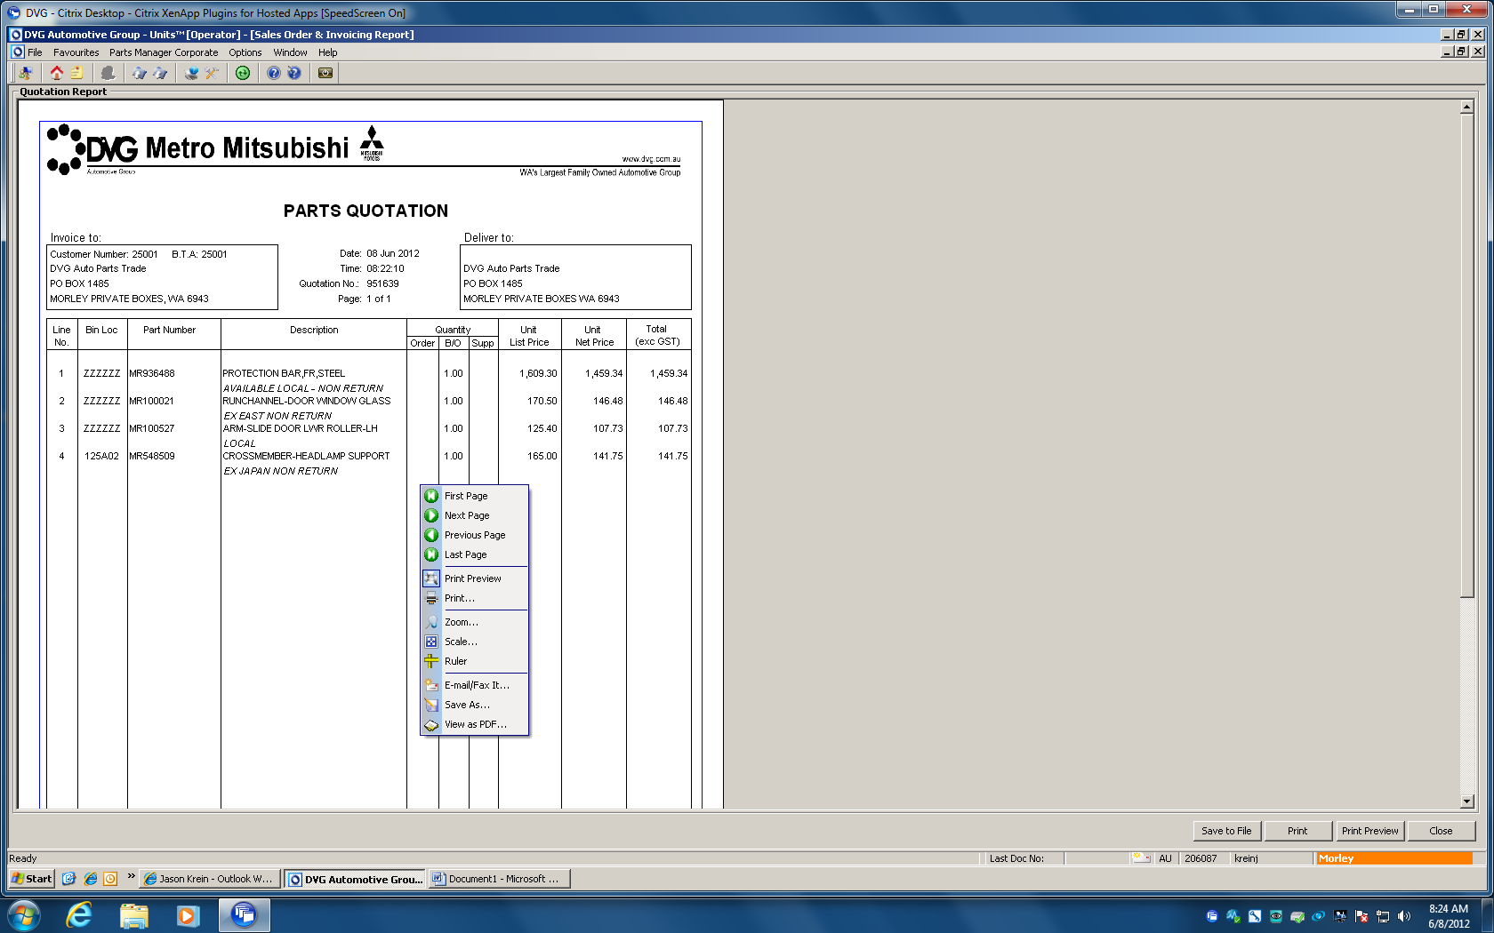

- Click on Save as and drop the box to XML

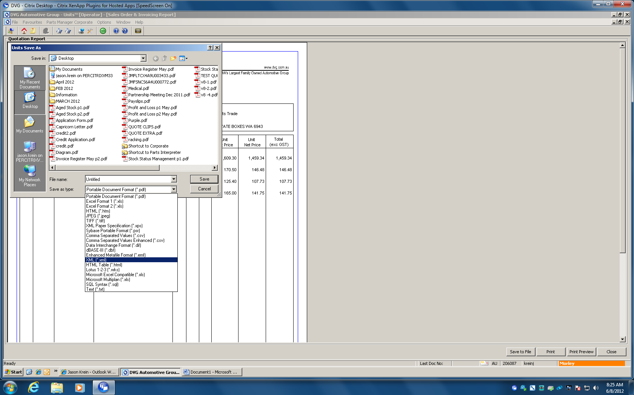

- Name your file and hit Save

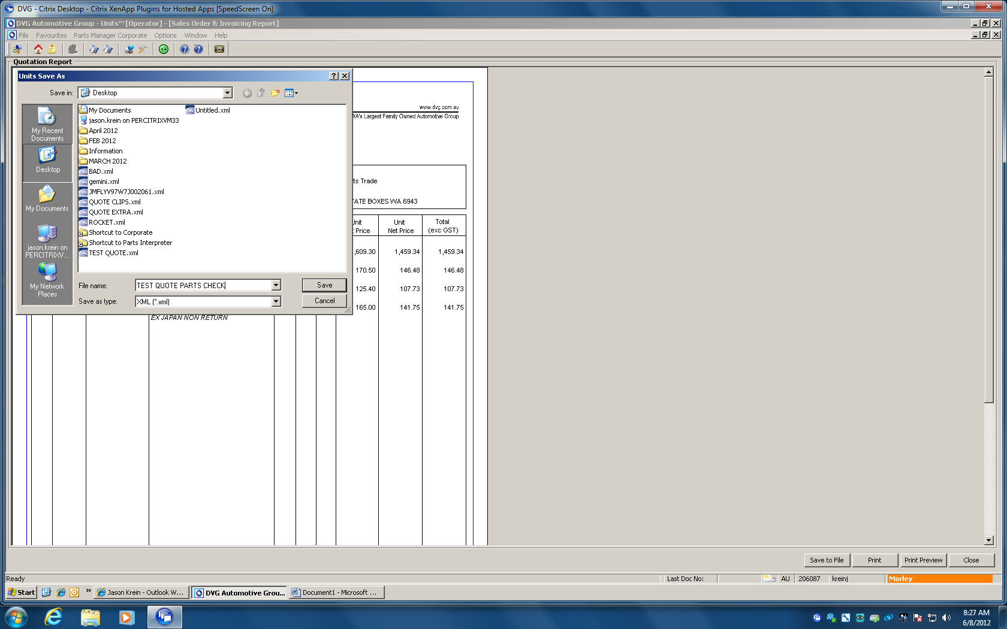

5. Your file is now ready to be uploaded to Parts Check

